Social Story – Instructions for Use
This social story can be used prior to the service to help people know what to expect. For some people, knowing what will happen can help them to take part.
There is space in this template for you to add the name of your church and photos of the environment.
Once you have done this, it can be printed or emailed for anyone who needs it.

ENCOUNTER Service
My name is _________________.
On Sunday morning, I am going to Click here to enter the name of your church for the ENCOUNTER service. | 
Someone will say “hello” to me. They are being friendly. | 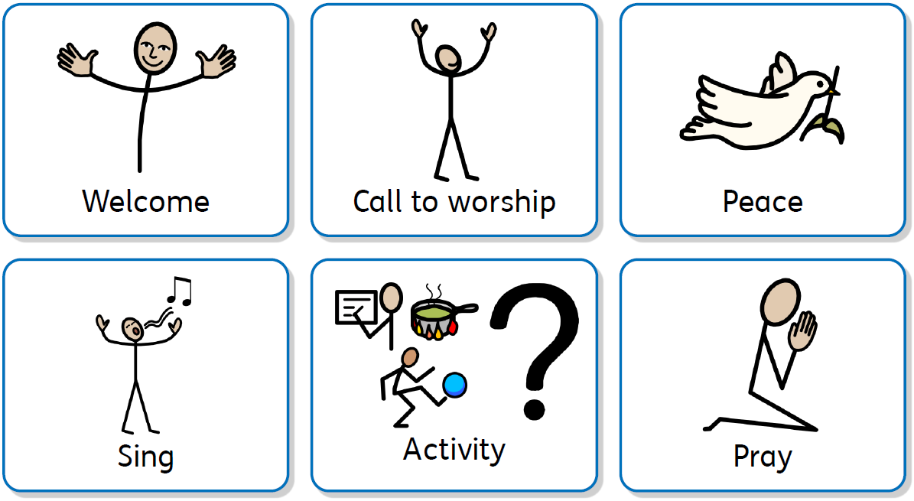
The church will look like this. I can sit on any empty seat, or on the cushions.
There will be a visual timetable on the screen for me to look at. This will help me to know what is happening and what is next. | 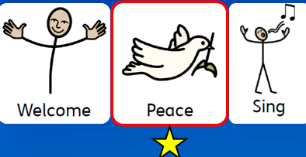
The person leading the service will tell us what the theme is. Then there will be The Peace. Sometimes we say ‘Peace’ to people and shake hands or we talk to the people near us. I can join in with this, but I do not have to.
During the service, we will sing songs. I can stand up or sit down to sing. It is OK to dance, move around or play the instruments that will be at the front of the church.
The leader will help us say prayers. Sometimes I need to sit quietly to pray. Sometimes, I will be told how I can join in. I can say “amen” at the end if I agree with them.
There will be an ‘activity’ during the service. This is where something different will happen. It could be a game, a quiz, a video or something else. I can join in with this.
We will hear a reading from the Bible. I will be able to see the Bible reading on the screen. There might be pictures or a video for me to look at. I need to listen to the reading. | 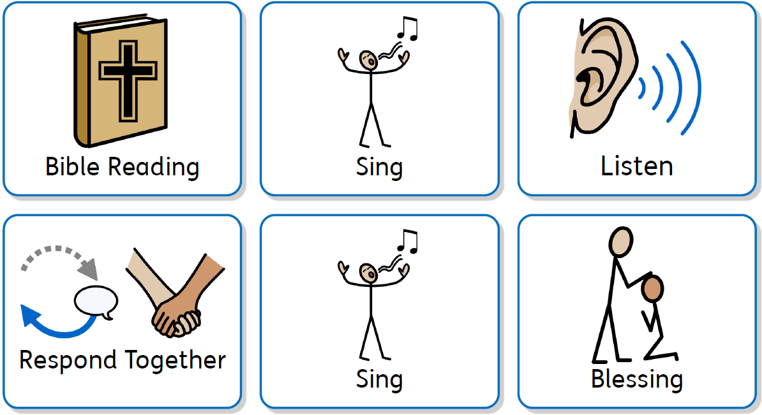
The preacher will tell us what the Bible reading means. This will be short. I need to listen to what they are saying.
There will be a time to respond. This is a time for me to ‘do’ something to show I agree with what was said. There will be different things I can choose. I do not have to join in, I could sit quietly in my seat.
After the service, I can have a drink and a biscuit and talk to people. If I don’t want to do this, that is OK, I can just go home.

